PROJECT REPORT

HR Management Project

# 

Name: Akshaya Anil Shivale

Project Title: HR Management Report

Language: Power BI

Date : 29-10-2024

Project Description:

This Power BI project aims to analyze sales data from the Superstore dataset to gain insights into orders, customers, profitability, and returns. Sales by product category and subcategory. Sales by region and state. Focus on high-profit products and reduce the inventory of low-profit or high return products.

Objectives:

1. Data Collection & Preparation:

• **Direct Extraction:** Exporting data from the HRIS, payroll, and other systems in formats like CSV, Excel, or directly connecting Power BI to these systems using APIs or database connectors.

• **Manual Data Entry:** In cases where the data is not readily available in digital formats, manual

entry may be required (e.g., in performance evaluations or custom survey results).

• **Data Aggregation:** In some cases, data might need to be aggregated from multiple systems or

departments, such as consolidating employee performance, payroll, and attendance data to form a

comprehensive employee profile.

2]Data Transformation**:**

• **Change data types**: For example, ensure numerical data is recognized as numeric values, date fields as date types, etc.

• **Create calculated columns or measures**: You can create new columns or measures in Power BI for derived metrics like:

* **Turnover rate** = (Number of employees who left / Average number of employees) * 100
* **Average tenure** = (Total years of experience / Total number of employees).

• **Create new hierarchies or categories**: For example, categorizing employees based on performance or grouping by department or job role.

3] Data Modeling:

• **Relationships between tables**: Define relationships between tables to allow for efficient filtering and reporting (e.g., linking employee data to payroll or performance data).

• **Fact and dimension tables**: Organize data into fact (numeric, transactional) and dimension (descriptive) tables.

• **Time intelligence**: Set up date tables to perform time-based analysis (e.g., quarterly performance trends, turnover rates over time).

• **Data security**: Ensure that sensitive HR data (such as salary or personal information) is securely handled using Power BI’s row-level security (RLS) if required.

4] Visualization & Reporting:

Once the data is prepared, you can begin creating Power BI reports and dashboards that provide meaningful insights. These can include:

* **Employee performance dashboards** that track individual and departmental performance.
* **Retention and turnover analysis** showing trends over time.
* **Compensation analysis** comparing salary ranges by job role, department, etc.
* **Training and development tracking** to monitor employee training programs.

5] Snapshots:

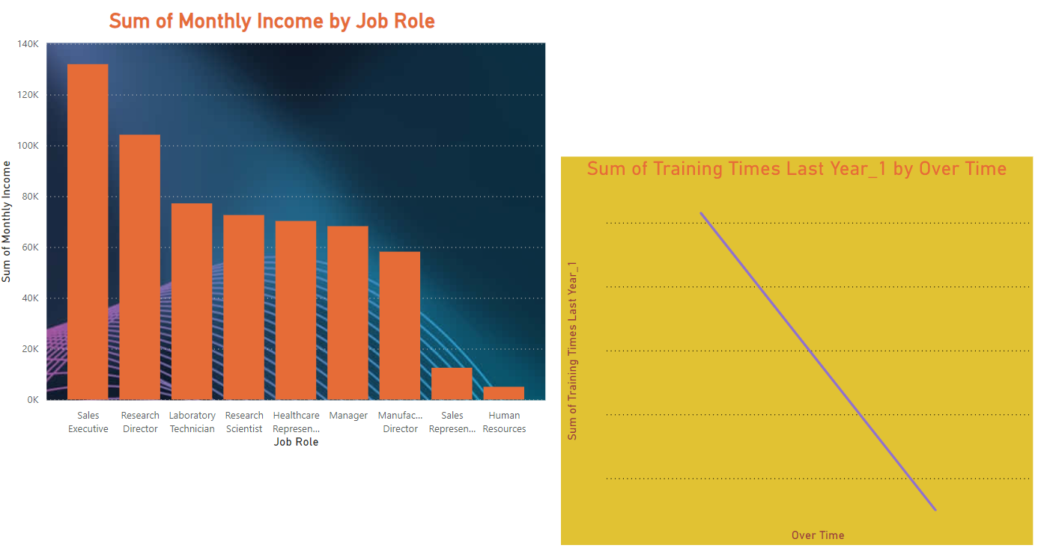

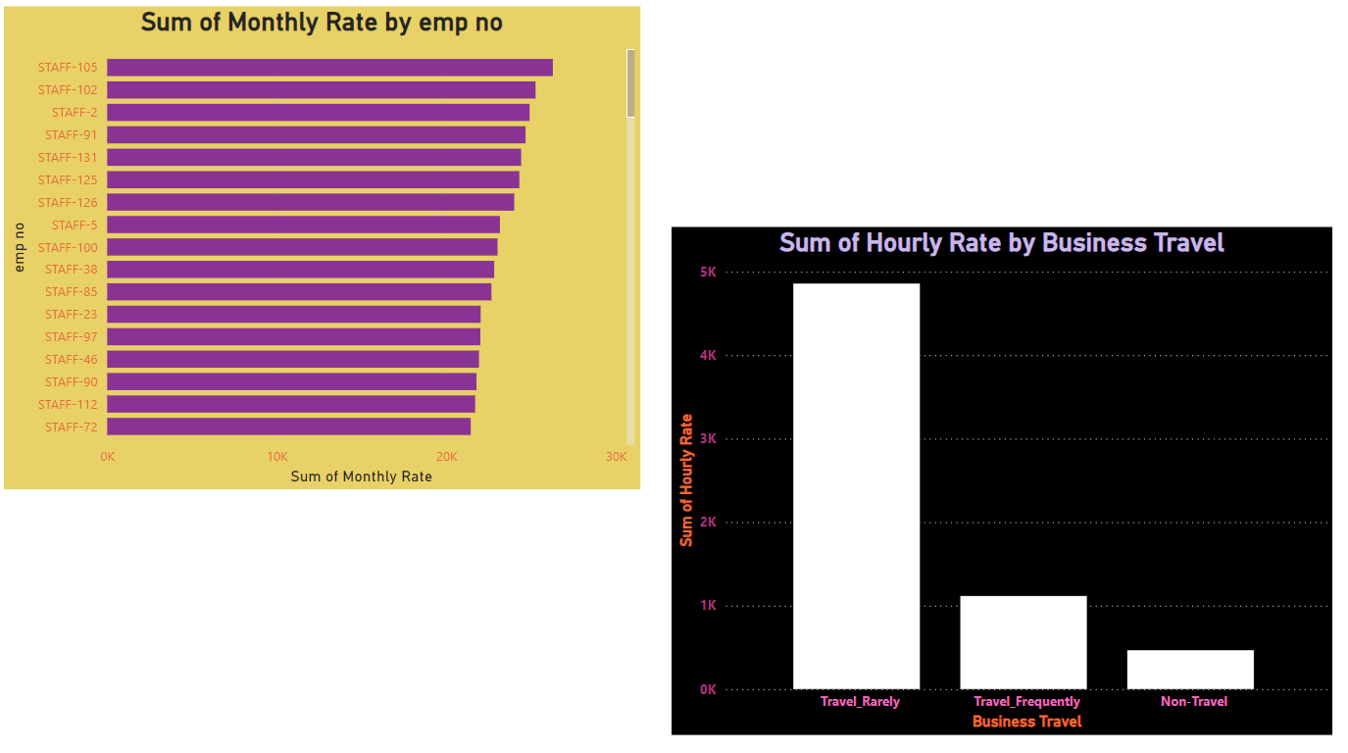

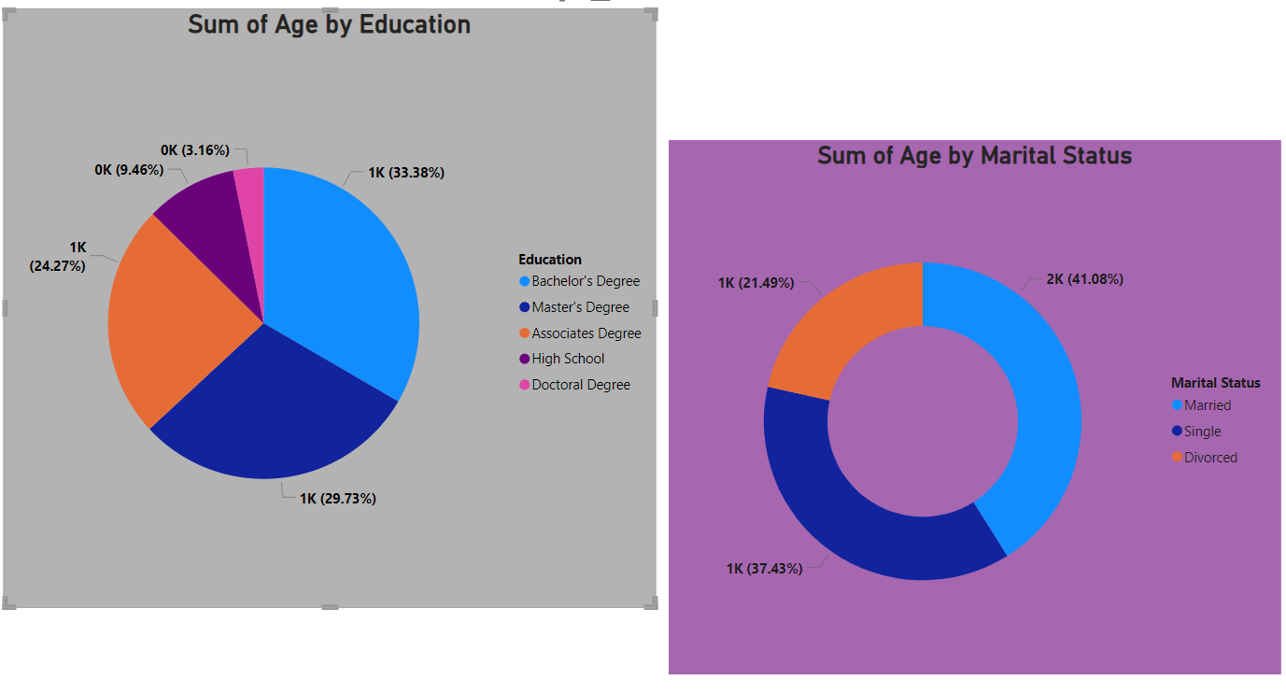

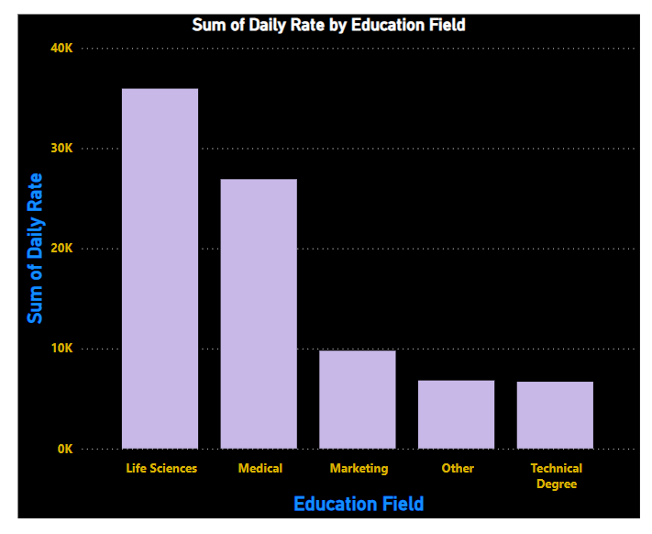

➔ Conclusion:

The Power BI HR Management project has successfully demonstrated the potential of leveraging business intelligence tools to enhance the management and analysis of HR data. Through comprehensive data collection, preparation, and visualization, this project has enabled the extraction of actionable insights that can drive better decision-making and improve organizational efficiency.